* 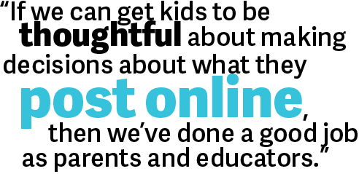

# October is Cyberbullying Awareness Month

Students of all ages should know some rules to follow and how to be a responsible citizen when on-line, for safety sake!

I have been putting together lessons for grades K-5 focusing on Cyberbullying, Internet Safety, and Privacy.

Please contact me to set up a time and date.

**K-12**

Common Sense Media has many lessons, activities, and videos about Digital Citizenship and how to keep our students safe!

[Common Sense Media](https://www.commonsensemedia.org/educators/scope-and-sequence)

**Everyone**

Visit [Stay Safe On-line](https://www.staysafeonline.org/stay-safe-online/for-parents/raising-digital-citizens), learn ways to protect yourself, your family, and your students.

**K-2**

[Brain Pop Jr](https://jr.brainpop.com/artsandtechnology/technology/internetsafety/).

[Franklin-McKinley Schools](http://www.fmsd.org/District/1566-Internet-Safety-Curriculum-Grades-K-2.html)

**All Ages**

[**6 Games to teach Internet Safety**](http://www.makeuseof.com/tag/6-internet-safety-games-kids-cyber-smart/)

### Websites/Apps

### Worth Mentioning

#### October is the Month for:

##### National Techie Day

##### Cybersecurity

##### Awareness

##### Month

##### National Bullying Prevention Month

### A Newsletter

To Keep You Informed

Tech Bits and Bytes

October 2015

October 3rd is National Techie Day! I am not making this up!

**I would like to know what you are using in the classroom and how you are using it to meet your class objectives! Send me an e-mail and share your ideas.**

# Overwhelmed? Take it one Google App at a time!

# Kathy Keough

# Sharing is caring

###### What is your go-to Smart Board learning tool?

Here we are, October, almost one month into the school year. What have you learned about Google Apps for Education? Are you proficient enough to help your students in Classroom, Drive, Docs, Sheets, Slides, Forms, Drawings, etc.? Of course not! Give yourself a break; this is new for the majority of you. Here’s my advice: learn one App at a time. If you are using Classroom, stick with Classroom until you feel comfortable moving onto the next challenge. If you start out using Docs, then use Docs exclusively until your confidence builds then move onto the next. Don’t worry about the students getting bored, how are you going to help them if you aren’t confident using it? There is no pressure to learn it all at once. Alleviate some stress and do not get overwhelmed, take it one App at a time. Remember, I am always here to help.

