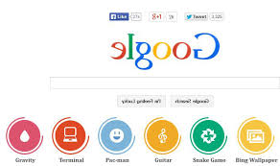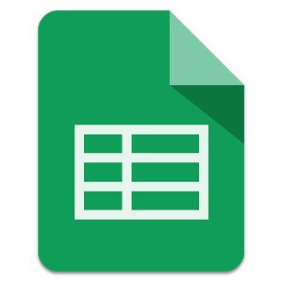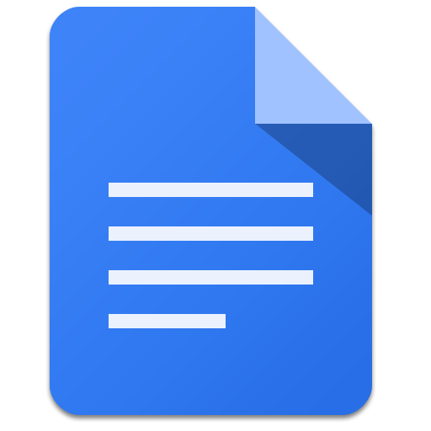

Watch for Voice Typing coming to Google Docs in the next couple of weeks! Students can type a document without touching the keyboard! Watch a video tutorial by clicking the link below.

[Youtube](https://www.youtube.com/watch?v=q96L66XJouU)

1

Visit daily to see what 4 Star apps are available for free download today!

[Apps gone Free](http://appadvice.com/appnn/tag/appsgonefree)

September is a busy time of year for all of us. Learning names, writing lesson plans, and accommodating all of our students’ needs can be overwhelming. Not to mention changes to curriculum and standards, standardized testing, and even incorporating technology into the classroom (it’s great when it works!), can all add extra challenges to your already stressful day!

Allow me to take some of the stress out of your day. I can teach lessons, research apps/software, prepare presentations, provide individual or group tutorials in Google Apps for Education including Docs, Drive, and Classroom, Microsoft Office, Chrome Browser add-ons and extensions, and so much more!

Please feel free to contact me to set up a time. Stop me in the hall, send me an e-mail, drop by the Aitken Library or the Martin Conference Room.

[keoughk@seekonkschools.org](mailto:keoughk@seekonkschools.org)

#### Google Tips

K-3 Sight words offers free resources to teach younger students reading strategies.

[Sight Words](http://www.sightwords.com/)

Free resources, lesson plans, and interactive activities for K-8. You can register for free but it is not required.

[National Council of Teachers of Mathematics](http://www.nctm.org/Classroom-Resources/Interactives/)

**ELA**

**Free Apps**

## **Websites/apps worth mentioning**

A bi-monthly newsletter to keep you informed in Technology for Education.

# Welcome

**Math**

Tech Bits and Bytes

September 2015

Kathy Keough

September 2015 Issue 1

By: Kathy Keough

The time is here. We are going Google! It is not going to be a seamless transition and change can be challenging for some people but give yourself some time, you will eventually get the hang of it.

There are benefits from using Google Apps for Education. One of them is the Google Drive. All your files and folders are in one place. It can be a little confusing and I hope I can make it a little easier for you.

**Google Drive**

Think of it this way. Your Google Drive is your file cabinet draw, inside your draw you have folders, inside these folders are your Docs (word processing documents), Slides (slideshow presentations), Sheets (spreadsheets), Forms, Drawings, etc. Your documents are automatically saved in your Drive as long as you are signed in with your seekonkschools credentials and you are using Google to create your documents. Other documents such as MS Word, PowerPoint, PDFs, and more can be easily transferred into your Drive. The benefit is having all your files in one place or one drawer, your Drive, that you can access anywhere.

One the downside, using Google Drive can be a little confusing at first and a little unorganized especially documents that have been “shared” with you. That’s for another day. Take it one step at a time. If you need assistance, I am here.

Is there an app or website that you cannot live without? Whether you use it in the classroom or it’s a go-to for planning and you would like to share it with others, I would love to get the word out. Send me a link and I will share it through this newsletter.

**My go-to sites**

YouTube- Everything from a quick tutorial to a full-length documentary. I can usually find just what I need, for students or me. Since, Google owns YouTube it works well within Google Apps for Education.

Another great resource for me is the Google Training site. [Google Training](https://edutrainingcenter.withgoogle.com/resources/tools) provides resources for all Google Tools including, YouTube, Classroom, Calendar, Chromebooks, and many more! Also, the site provides ideas from other teachers. Check it out.



Tech Bits and Bytes September 2015

## Have an App or website you want to share?

### The pros and cons

# A School District Going Google