* 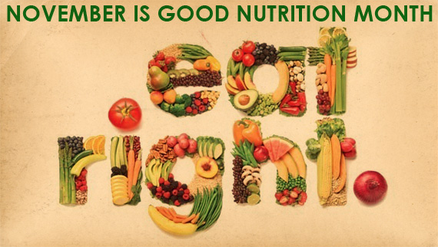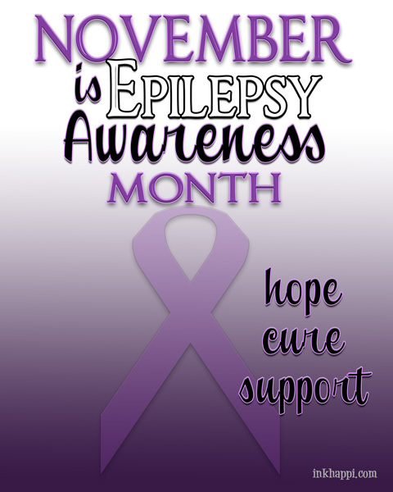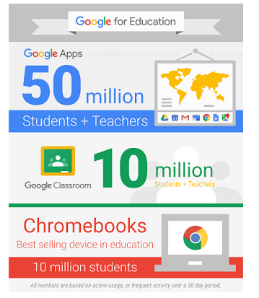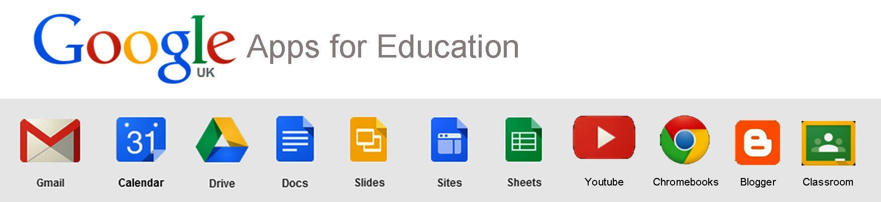

Also, [American Education Week](http://www.nea.org/grants/19823.htm)

Have your students color a community helping citizens [calendar page](http://www.educationworld.com/a_lesson/calendar/november.shtml)

My website is up and running check it out! [Seekonk Tech Integration](http://seekonktechintegration.weebly.com/)

**READING**

ReadWorks offers free reading passages with a Thanksgiving theme! K-12

[Read Works](http://www.readworks.org/rw/thanksgiving-2014-reading-passages)

**CREATIVITY**

**Have your students create storyboards about Thanksgiving! Free teacher trial!**

[StoryBoard That](http://www.storyboardthat.com/education/learn-more-about-classroom-portals)

**VIRTUAL FIELD TRIPS**

Take your students on a virtual tour of the Mayflower. Lesson Plans for the Common Core for grades K-8

[Scholastic Thanksgiving](http://www.scholastic.com/scholastic_thanksgiving/voyage/)

# November is

# Good Nutrition Month

#### November is the Month for:

### Websites/Apps

### Worth Mentioning

### A Newsletter

To Keep You Informed

Tech Bits and Bytes

November 2015 Issue 1

Newsflash

It looks like Chrome and Android are going to merge. Slated for 2017?

**I would like to know what you are using in the classroom and how you are using it to meet your class objectives! Send me an e-mail and share your ideas.**

I came across an interesting article in [*EdTech Magazine*](http://www.edtechmagazine.com/k12/article/2015/10/google-education-gains-momentum-50m-app-users-10m-chromebook-users)written by D. Frank Smith. He stated that Google Chromebooks and Google Apps for Education are “on a winning streak with K-12 sector”. Google launched their Classroom app in August 2014 and since then it has gained more than “10 million” users! What an incredible growth for Google. According to the article, “more than 50 million students and teachers are using Google Apps for Education.” That’s more than 10 times the population of Massachusetts. Kudos to Google for accomplishing this milestone and kudos to Seekonk Public Schools for jumping on the bandwagon. To read the complete article, click on the link or [here](http://www.edtechmagazine.com/k12/article/2015/10/google-education-gains-momentum-50m-app-users-10m-chromebook-users). 50 million can’t be wrong!

# We Must Be Doing Something Right

# Kathy Keough

# Sharing is caring

###### What is your go-to Thanksgiving Site?