* 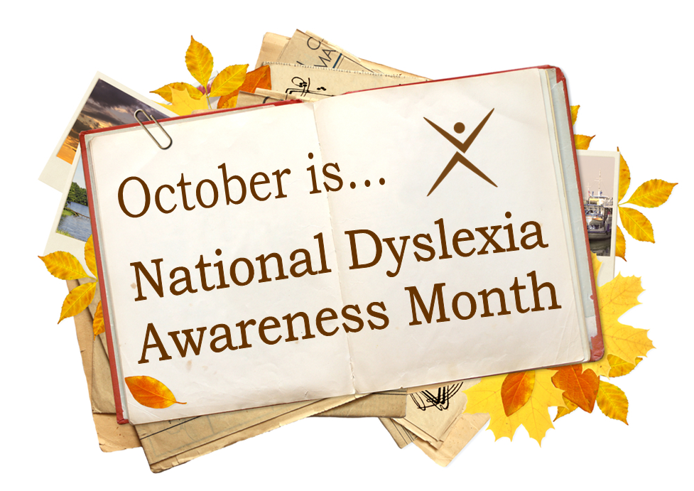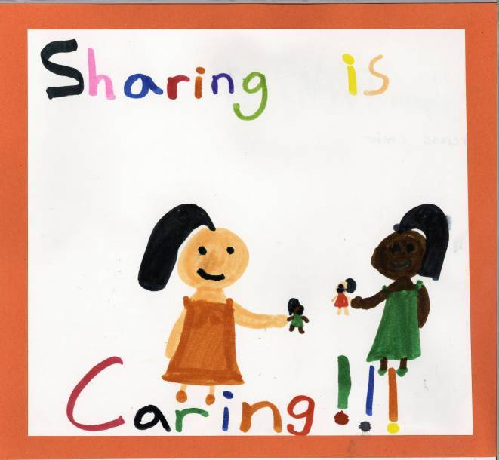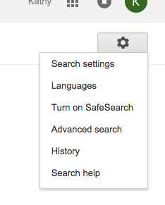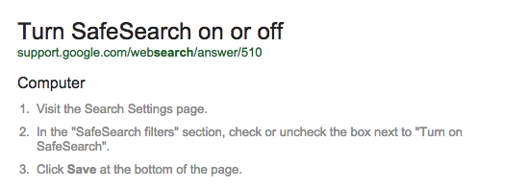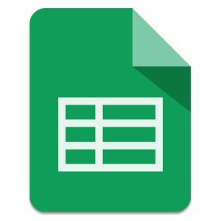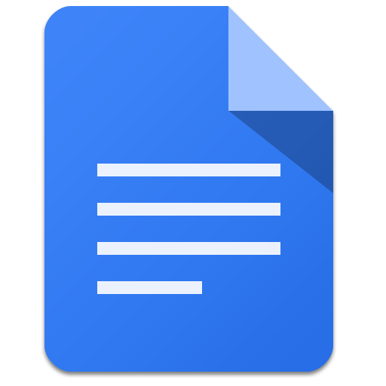

It is never too early to introduce our students to the importance of STEM (Science, Technology, Engineering, and Math)! This newsletter’s focus is bringing you STEM resources that you can use with your students.

My website is up and running check it out! [Seekonk Tech Integration](http://seekonktechintegration.weebly.com/)

#### October is the Month for:

**ENGINEERING**

Bring STEM into your classroom. Visit Curiosity Machine to bring the Engineering Design Process into K-12!

[Curiosity Machine](https://www.curiositymachine.org/home/)

**MATH**

A free website where [Math is Fun!](https://www.mathsisfun.com/) Tons of resources for all ages!

**SCIENCE**

[Mosa Mack](https://www.mosamack.com/) has some free Science units and videos. It looks like a very promising website! CCSS/NGSS

**STEM LESSON PLANS**

I hit the mother lode when I stumbled upon[**Sam Houston Elementary School STEM page**](http://www.maryville-schools.org/site/Default.aspx?PageID=4713)

# October is STEM Awareness Month!

### Websites/Apps

### Worth Mentioning

### A Newsletter

To Keep You Informed

Tech Bits and Bytes

October 2015 Issue 2

There are so many tips and tricks when using Google it is impossible to know them all. There is a “Safe Search” feature built into Google Search. It just needs to be activated. If you are concerned that your students will stumble upon a risqué website, even with the schools’ filters it could happen, then have your students enable “Safe Search”. To activate: On Google Search page click the gear icon, and simply turn on Safe search. “SafeSearch On” will appear when enabled.

# Safe Searching for Kids with Google

# Kathy Keough

**I would like to know what you are using in the classroom and how you are using it to meet your class objectives! Send me an e-mail and share your ideas.**

# Sharing is caring

###### What is your favorite site for lesson plans?